Interactive computer graphics

Example exam questions

Željka Mihajlović
Marko Đurasević

- a) Determine the parametric equation $B(t)$ of the Bezier curve given with points $P_{1}=(0,0)$, $P_{2}=(1,1)$, $P_{3}=(2,1)$, $P_{4}=(3,2)$. Calculate the point of the Bezier curve for the parameter value $t=0.3$.
b) For the Bezier curve from part a) determine the equation of its derivative $B'(t)$. Determine the value of it’s derivative for the parameter value $t=0.7$.
c) How could we calculate the equation of a Bezier curve $B_{1}(t)$ which passes through (interpolates) all four points from part a)? Determine the parametric equation of one such Bezier curve. Determine the point of this curve for parameter value $t=0.5$.
- A 3D body is defined as specified by the .obj file shown in Figure 1. If the eye of the spectator is located at point $eye=(3, 3, 3)$, determine which polygons of the given 3D objects would be rear polygons when looking from the $eye$, and which would be front polygons. Can this algorithm be used to determine which polygons are visible and which are not? Explain. If it can be used, would it work for all 3D objects?
# unknown_model.obj
v 1.00 1.00 1.00
v 2.00 1.00 1.00
v 1.00 2.00 1.00
v 1.00 1.00 2.00

f 1 3 2
f 1 4 3
f 1 2 4
f 2 3 4
- A rectangle is defined with vertices $P_{1}=(0,0)$, $P_{2}=(100,0)$, $P_{3}=(100,100)$, $P_{4}=(0,100)$. For each vertex an intensity is defined $I_{1}=10$, $I_{2}=25$, $I_{3}=15$, $I_{4}=30$ (where intensity $I_{1}$ is the intensity for vertex $P_{1}$, intensity $I_{2}$ for vertex $P_{2}$, etc.). Determine the intensity of point $P=(25, 55)$ by using bilinear interpolation.
Figure 1 Body definition
- The eye of the spectator is located at $eye=(3, 1, 4)$, and is looking towards point $\left(0,0,0\right)$. The look-up vector is define as $v_{up}=(1,1,0)$. Determine the transformation matrix which would transform points from the global coordinate system to the coordinate system of the spectator (which is defined by the eye, point towards which the spectator is looking, and the view-up vector). Determine the inverse transformation, one which would transform points from the coordinate system of the spectator to the global coordinate system. With these two matrices demonstrate how point $P=(1,1,1)$ would be transformed from the global coordinate system to the coordinate system of the spectator and then back.
- In a scene four lines are defined as illustrated in Figure 2. Each of these lines is denoted with a letter.
a) Given these four lines construct the BSP tree (note: when using the algorithm the letters denote the priority of the lines, i.e. the line denoted with letter A should be visited first).
b) By traversing the BSP tree determine the order by which the polygons should be drawn in the scene, if the viewing location is given in the point denoted as eye.

Figure 2 Lines in a scene
- Find the intersection points between the sphere given with the following equation ${\left(x-1\right)}^{2}+{\left(y-4\right)}^{2}+z^{2}=16$ and the line given by the parametric equation: $P(t)=\left[\begin{matrix}1 \\ 2 \\ 3\end{matrix}\right]+t\left[\begin{matrix}1 \\ 0 \\ -2\end{matrix}\right]$.

- Let the eye of the viewer be located at $eye=\left(1,1,1\right),$ and that he is looking at point (0,0,0). Let the projection plane be located at $z=0$. Determine the projection of point (5,3, -2) on the projection plane by using the orthographic parallel projection and the perspective projection (calculate the matrices for both these projections).

- The position of the light source is $L=(5,7,5)$, while the position of the spectator is $eye=(3,2,4)$. By using the Phong illumination model (consisting out of the ambient, diffuse and specular component) calculate the intensity of the light at the centre of the polygon given with the following three points: $P_{1}=(1,1,1)$, $P_{2}=(2,2,0)$, $P_{3}=(1,3,1)$. The intensity of the light source for all components is $I=0.7$, while the reflection constant for the ambient, diffuse and specular components are $k_{a}=0.3, k_{d}=0.9$, $k_{s}=0.5$, respectively. The shininess constant for the specula component is equal to: 2.
- The screen area is defined with the dimensions 512x512 pixels.
- Determine to which number in the complex plane the pixel with coordinates x=240, y=370 would be mapped, if it is mapped to a complex plane which where the real coordinate is between [-2,2], and the imaginary coordinate is between [-1.5,3].
- For the point calculated in the a) part of the task, determine whether it belongs to the Mandelbrot set. We will suppose that the number belongs to the Mandelbrot set if the modulo of the number in each iteration of the recursive formula does not exceed 2. Perform five iterations of the recursive formula and test whether it belongs to the Mandelbrot set or not.
- Let the clipping polygon be defined by the vertices: $P_{1}=(5,5)$, $P_{2}=(20,2)$, $P_{3}=(16,10)$, $P_{4}=(10,10)$. Perform the Cyrus Beck clipping algorithm for the line between points $L_{1}=(1,2)$ and $L_{2}=(23,12)$. For each intersection parameter determine whether it is “entering” or “leaving”. Finally, determine the parameters that are of interest, and the points which represent the start and end of the clipped line.
- Let the screen drawing are be limited only to pixels between coordinates 100 and 500 for the x and y coordinates. Use the Cohen-Sutherland algorithm to determine which part of the line given with points $L_{1}=(20,50)$ and $L_{2}=(700,650)$ will be drawn.
- For the 3D body in Figure 1 determine the normal for each vertex. If the RGB colour intensities for the vertices are defined as: $I_{1}=(15,35,70)$, $I_{2}=(170,100,25)$, $I_{3}=(200,17,150)$, $I_{4}=(33,158,231)$, determine the intensity at point $P=(1.3,1.6,1)$ by using Gouraud shading.
- For scan lines a, b and c from Figure 3 determine the edges which contains the Active edge list. Determine the surface flag which is active between each pair of edges.
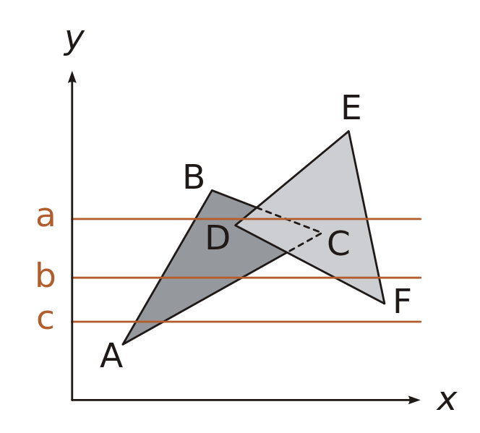
Figure 3 Two polygons in space

